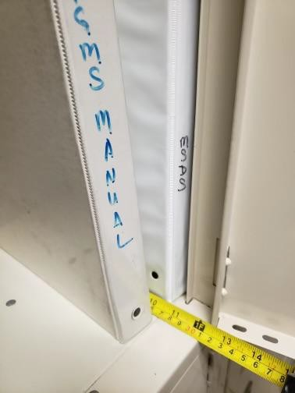
Piney Grove 7th Grade Supply List 2024 - 2025
Note: These supplies will need to be replenished throughout the year. Project specific supplies will be requested by teachers on an as needed basis.
Students may need additional supplies for connection courses. Please label all of your student’s supplies.
All binders must be less than 11 inches to prevent jams/damages.
1 1/2 in. 3 ring Binder  (qty 4)  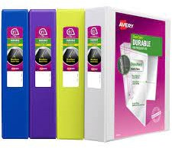 | 4 Packs of Binder Dividers (20 tabs total)  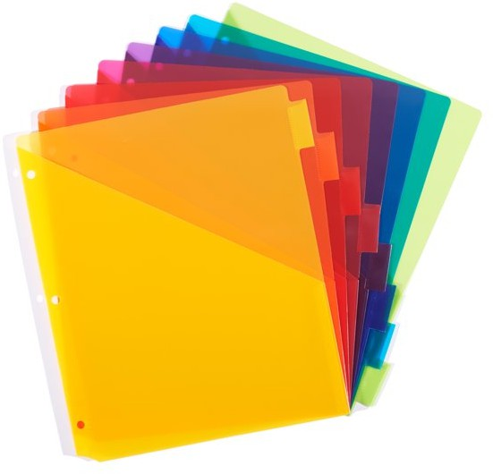 | Loose Leaf Notebook Paper (qty 3 packs)  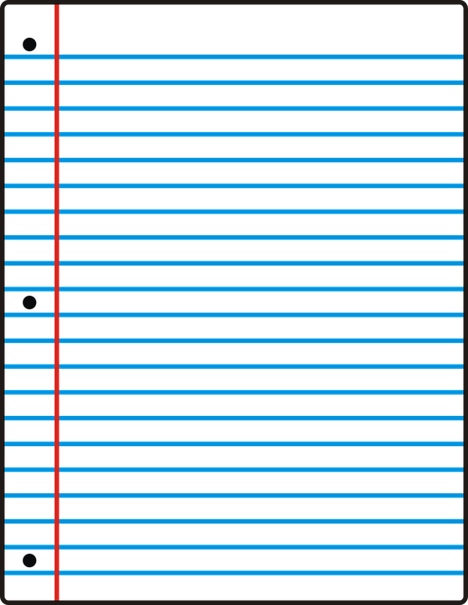  College Rule | 3 Prong Folder w/ Pockets  (qty 2 Homeroom & Homework)  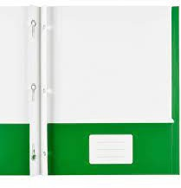
Pencil pouches (qty 1)  (For Craft Kit.)  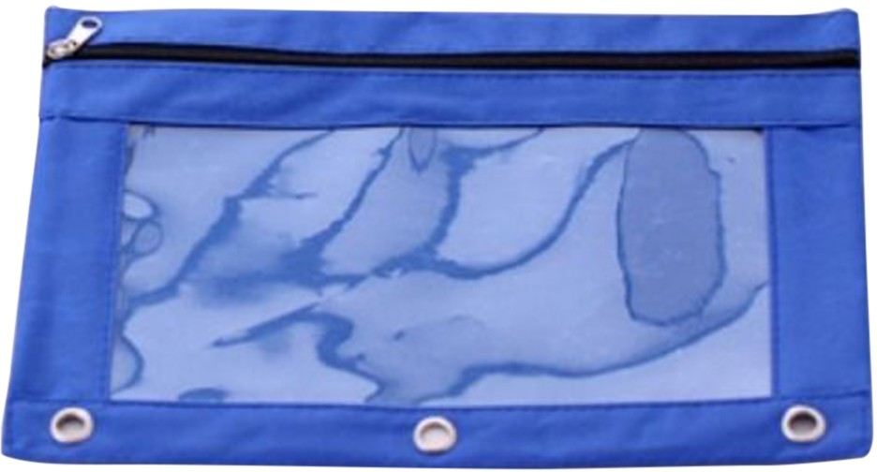 | 2 Glue Sticks  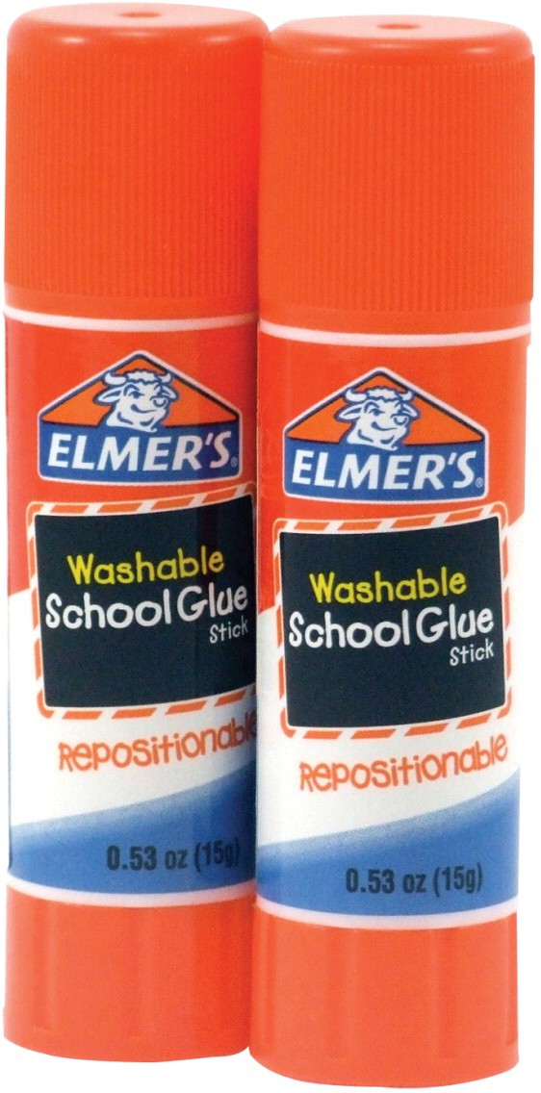 | Colored Pencils  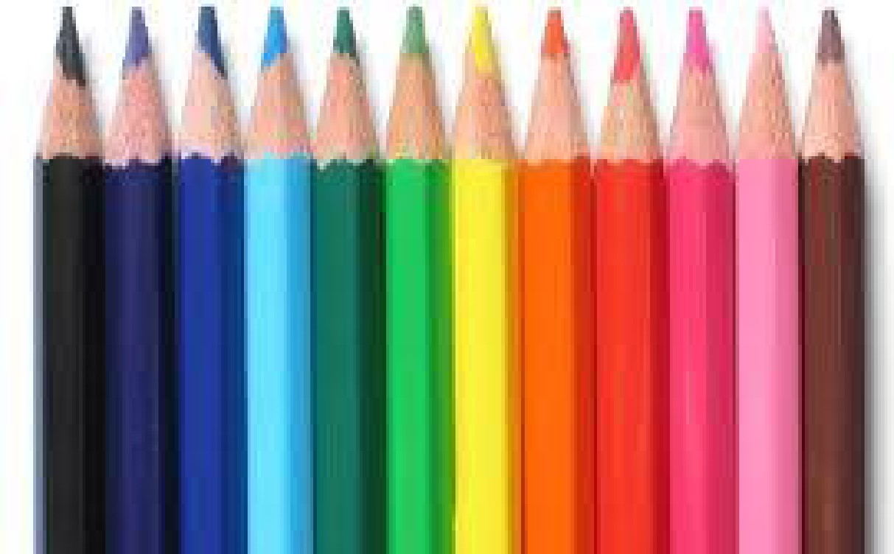 | Headphones that plug into a computer  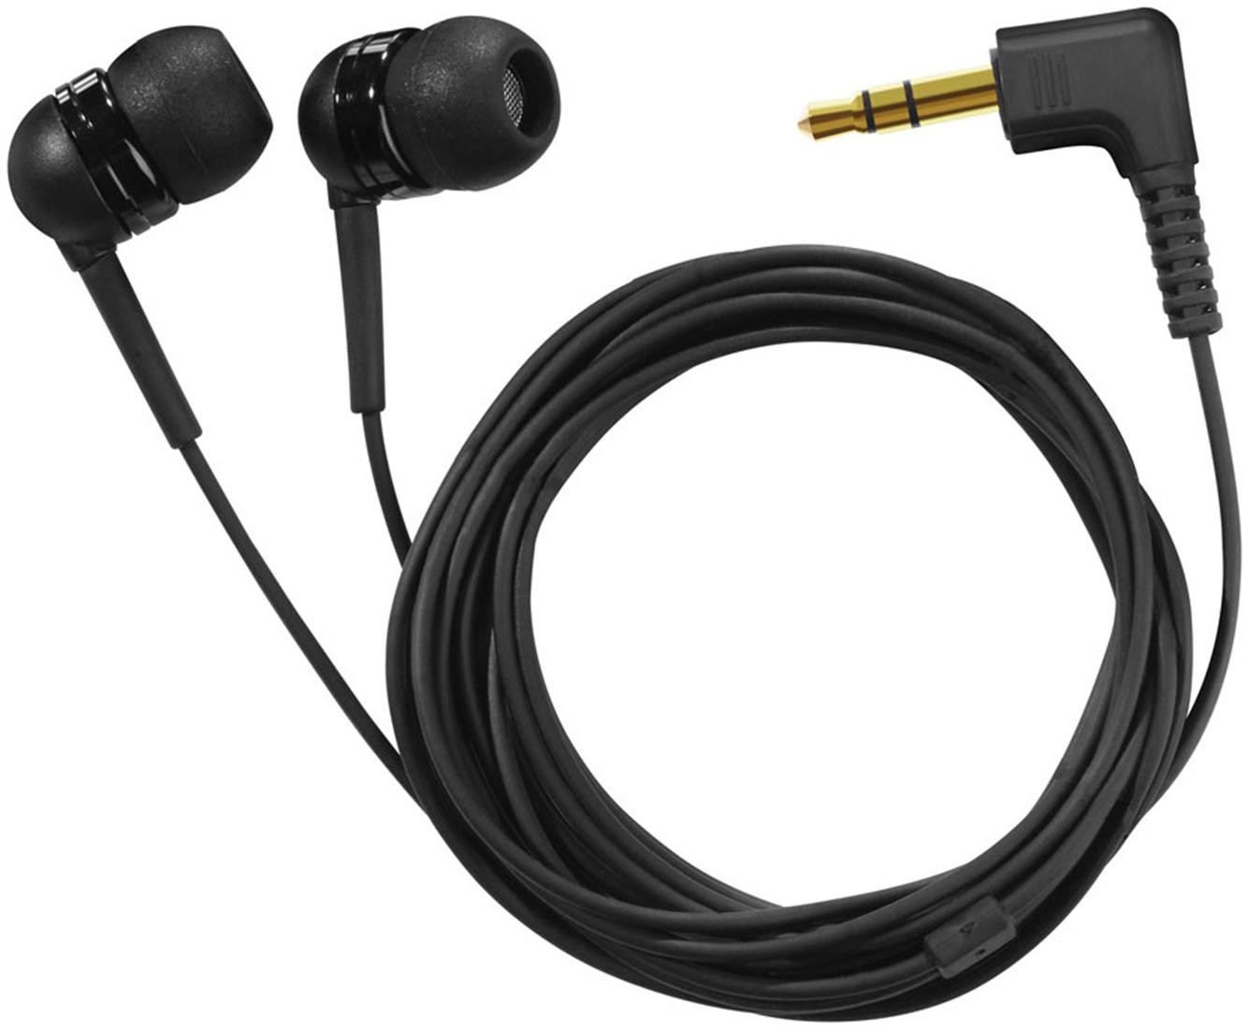
Expo Markers (qty 4) & Eraser Thin Markers  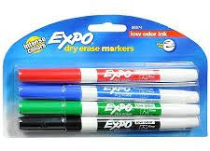 | Blue/Black Pens  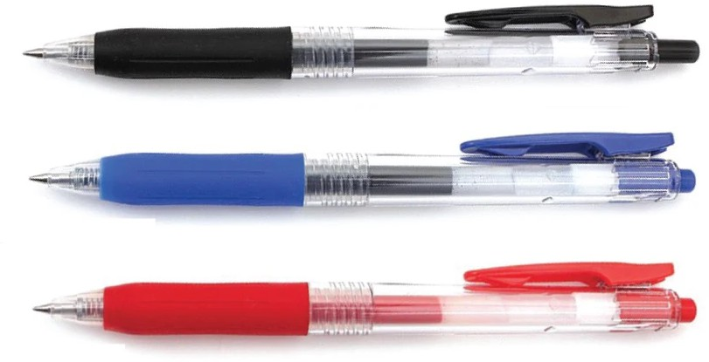 | 2 + Highlighters  (Different Colors)  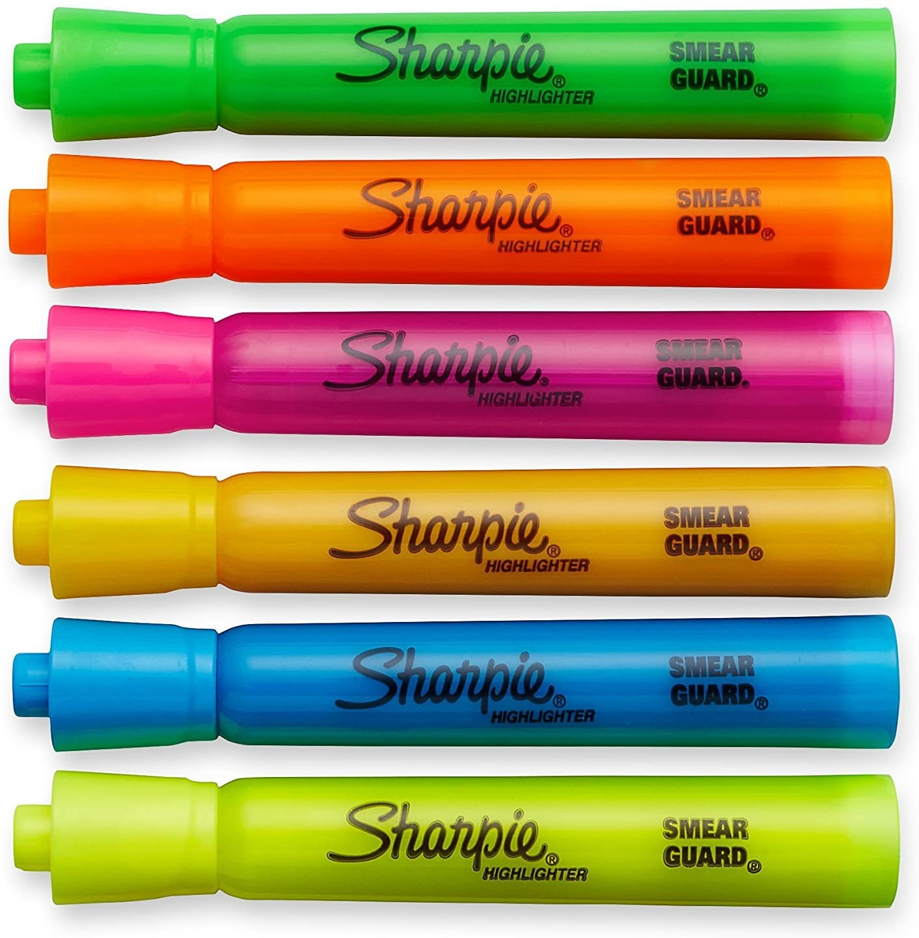 | 24 Pencils (Mechanical preferred)  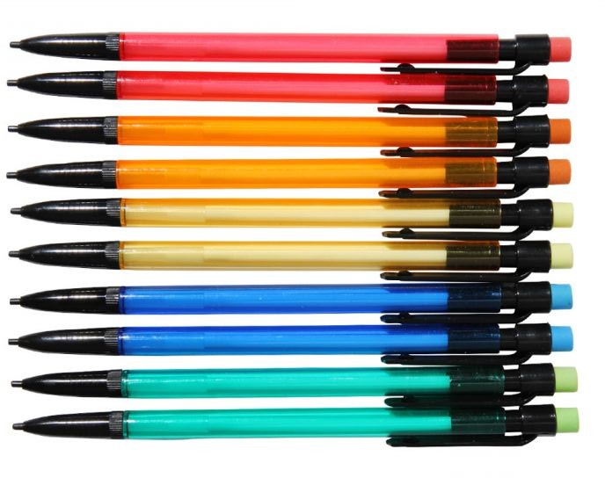

TI-30XS MultiView™ scientific calculator
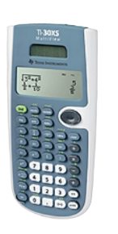
Optional: ChromeBook or Tablet (to allow for single student use)

